**Working with neural networks**

***Subpackages***

Neural-related functionality is located in two ALGLIB subpackages:

* mlpbase - basic neural functions (processing, modification) and data structures not related to training
* mlptrain - functions and data structures used to train neural networks

***Creating trainer object***

If you want to train one or several networks, you should start from *trainer object* creation. Trainer object is a special object which stores dataset, training settings, and temporary structures used for training. Trainer object is created with mlpcreatetrainer or mlpcreatetrainercls functions. First one is used when you solve regression task (prediction of numerical dependent variables), second one is used on classification problems.

Trainer object can be used to train several networks with same dataset and training settings. In this case, networks must be trained one at time - you can not share trainer object between different threads.

***Specifying dataset***

Next step is to load your dataset into trainer object. First of all, you should *encode* your data - convert them from raw representation (which may include both numerical and categorical data) into numerical form. ALGLIB User Guide includes [article](https://www.alglib.net/dataanalysis/generalprinciples.php) which discusses how to encode numerical and categorical data.

After your data were encoded and stored as 2D matrix, you should pass this matrix to mlpsetdataset function. If your data are sparse, you may save a lot of memory by storing them into sparsematrix structure (see description of sparse subpackage for more information) and pass it to mlpsetsparsedataset

**Note #1**  
ALGLIB performs automatic preprocessing of your data before training, so you do not need to shift/scale your variables, so they will have zero mean and unit variance. Data are implicitly scaled before passing them to network. Network output is also automatically rescaled before returning it back to you.

**Note #2**  
Using sparse matrix to store your data may save you a lot of memory, but it **won't** give you any additional speedup. You just save memory occupied by dataset, and that's all.

***Creating neural network***

After you created trainer object and prepared dataset it is time to create *network object*. Neural network object stores following information: a) network architecture, b) neural weights. Architecture and weights completely describe neural network.

Neural architecture includes following components: number of inputs, number and sizes of hidden layers, size of output layer, type of output layer.

* *number of inputs* is determined by your dataset, you should choose exactly as many inputs as you have "input" variables in your dataset
* *hidden layers* can be chosen as you wish. You may choose network without hidden layers (input layer is connected directly to output layer), network with one or with two hidden layers. You are also free to choose number of neurons in each layer.
* *number of outputs* is again determined by your dataset
* *output layer* can be linear (used for regression problems) or SOFTMAX-normalized (used for classification problems). These two output layer types work well in most cases. You can also create networks whose outputs are bounded by interval or half-interval (specified during network creation).

After you decided on network architecture you want to use, you should call:

* mlpcreate0, mlpcreate1 or mlpcreate2 function to create regression network (linear output layer) with 0, 1, or 2 hidden layers.
* mlpcreatec0, mlpcreatec1 or mlpcreatec2 function to create classifier network (SOFTMAX output layer) with 0, 1, or 2 hidden layers.
* mlpcreater0, mlpcreater1 or mlpcreater2 function to create regression network with 0, 1, or 2 hidden layers and output layer with special activation function bounded by interval *[a,b]*.
* mlpcreateb0, mlpcreateb1 or mlpcreateb2 function to create regression network with 0, 1, or 2 hidden layers and output layer with special activation function bounded by half-interval.

***Training***

Current version of ALGLIB offers one training algorithm - batch L-BFGS. Because it is batch algorithm, it calculates gradient over entire dataset before updating network weights. Internally this algorithm uses [L-BFGS optimization method](https://www.alglib.net/optimization/lbfgsandcg.php) to minimize network error. L-BFGS is a method of choise for nonlinear optimization problems - fast and powerful optimization algorithm suitable even for large-scale problems. With L-BFGS you can train networks with thousands and millions of weights.

**Note #3**  
Other neural network packages offer algorithms like RPROP and non-batch methods. Benefits of **our** approach to neural training are: a) *stability* - network error is monotonically decreasing, b) *simplicity* - algorithm has no tunable parameters except for stopping criteria, c) *high performance* - batch method is easy to parallelize and to speed-up with SIMD instructions.

Individual network can be trained with mlptrainnetwork function. It accepts as parameters trainer object *S*, network object *net* and number of restarts *NRestarts*. If you specify *NRestarts>1*, trainer object will perform several training sessions started from *different* random positions and choose best network (one with minimum error on the training set). Commercial edition of ALGLIB may perform these training sessions in parallel manner, Free Edition performs only sequential training.

**Note #4**  
With *NRestarts=1*, network is trained from random initial state. With *NRestarts=0*, network is trained without randomization (original state is used as initial point).

ALGLIB package supports regularization (also known as *weight decay*). Properly chosen regularization factor improves both convergence speed and generalization error. You may set regularization coefficient with mlpsetdecay function, which should be called prior to training. If you don't know what Decay value to choose, you should experiment with the values within the range of 0.001 (weak regularization) up to 100 (very strong regularization). You should search through the values, starting with the minimum and making the Decay value 3 to 10 times as much at each step, while checking, by cross-validation or by means of a test set, the network's generalization error.

Also, prior to training you may specify stopping criteria. It can be done with mlpsetcond function, which overrides default settings. You may specify following stopping criteria: sufficiently small change in weights *WStep* or exceeding maximum number of iterations (epochs) *MaxIts*.

**Note #5**  
It is reasonable to choose a number in the order of 0.001 as a WStep. Sometimes, if the problem is very difficult to solve, it can be reduced to 0.0001, but 0.001 is usually sufficient.

**Note #6**  
A sufficiently small value of the error function serves as a stopping criterion in many neural network packages. The problem is that, when dealing with a real problem rather than an educational one, you do not know beforehand how adequately it can be solved. Some problems can be solved with a very low error, whilst 26% of classification error is regarded as a good solution result for certain problems. Therefore, there is no point in specifying "a sufficiently minor error" as a stopping criterion. UNTIL you solve a problem, you are unaware of the value that should be specified, whereas AFTER the problem is solved, there is no need to specify any stopping criterion.

Now, to the final point on the training of individual neural networks. mlptrainnetwork allows you to train network with just one call, but all training details are hidden within this call. You have no way to look deeper into this function - it returns only when result is ready. However, sometimes you may want to monitor training progress. In this case you may use a pair of functions - mlpstarttraining and mlpcontinuetraining - to perform neural training. These functions allow you to perform training step by step and to monitor its progress.

***Test set and cross-validation***

After you trained network, you can start using it to solve some real-life problems. However, there is one more thing which should be performed - estimation of its *generalization error*. Neural network may perform well on data used for training, but its performance on *new* data is usually worse. We can say that network results on the training set are optimistically *biased*.

One way to estimate generalization error of the network is to use *test set* - completely new dataset, which was **not** used to: train network, select best newtowk, choose network architecture, etc, etc. Network error on test set can be calculated with following functions: mlpallerrorssubset or mlpallerrorssparsesubset (for sparse datasets). They return several kinds of errors (RMS, average, average relative, ...) for part of the dataset (*subsetsize≥0*) or for full dataset (*subsetsize<0*).

Test set is a best solution - if you have enough data to make a separate test set, which is not used *anywhere else*. But often you do not have enough data - in this case you can use *cross-validation*. Below we assume that you know what is cross-validation and its benefits and limitations. If you do not know it, we recommend you to read a [Wikipedia article](http://en.wikipedia.org/wiki/Cross-validation_(statistics)) on this subject. Below is a quick summary on this subject:

* cross-validation procedure returns an estimate of the test set error - estimate, which was obtained using only training set
* cross-validation results are almost unbiased
* K-fold cross-validation is expensive procedure - it involves training *K* independent neural networks on *K* slightly different datasets.
* unlike test set, cross-validation does **not** estimate generalization properties of one specific neural network. It estimates generalization properties of the *neural architecture* combined with *training method* (specific algorithm used for training, stopping criteria, regularization, number of restarts, dataset). If you perform cross-validation, it is very important to use exactly same training settings (including number of restarts) as ones which were used to train network.

ALGLIB allows you to perform K-fold cross-validation with mlpkfoldcv function. As one of its parameters, this function accepts neural This function completely solves all CV-related issues (separation of the training set, training of individual networks, calculation of errors). We should remind that K-fold cross-validation is expensive procedure - it involves training of K individual networks, but Commercial Edition of ALGLIB can perform parallel training.

***Working with neural networks***

After you trained neural network and tested its generalization properties you can start actually using it! Most neural functions reside in the mlpbase subpackage. Link above will give you full list of functions, below we give just quick summary:

* processing function - mlpprocess, which returns network output *y* for input *x*
* serialization functions - mlpserialize and mlpunserialize, which allow to convert network to/from string.
* network examination/modification functions - about 20 functions which allow to explore network structure or modify its weights.

***Examples***

ALGLIB Reference Manual includes following examples:

* nn_cls2 and nn_cls3, which show how to solve classification problems with ALGLIB
* nn_regr and nn_regr_n, which show how to solve regression problems
* nn_trainerobject, which shows how to use trainer object
* nn_parallel, which shows how to use parallel training functions (Commercial Edition of ALGLIB)
* nn_crossvalidation, which shows how to use cross-validation functionality

**Performance and multi-core support**

***Tests description***

In this section we compare performance of two ALGLIB editions - Free and Commercial. All tests were performed on six-core AMD Phenom II X6 CPU running at 3.1 GHz, with one core left unused to leave system responsive. Thus, only 5 cores out of 6 were used. Following products were compared:

* managed core, Free Edition  -  100% NET code, C# interface.
* managed core, Commercial Edition - 100% NET code with multithreading support, C# interface.
* native core, Free Edition - generic C native code, C++ interface (**no C# interface!**).
* native core, Commercial Edition - highly optimized native core with multithreading support, accelerated by Intel MKL, **C++ and C# interfaces**.

As part of the test, we estimated performance of neural gradient calculation - operation which involves forward-backward pass through neural network. This operation consumes more than 99% of CPU time during network training, so it is very important to perform it as fast as possible. We performed test for neural networks with one hidden layer and SOFTMAX-normalized output layer, with same number of neurons in input/hidden/output layers. Synthetic dataset was used, large enough to demostrate benefits of highly optimized multithreaded code.

Commercial Edition of ALGLIB supports two important features: multithreading (both managed and native computational cores) and vectorization (native core). Free Edition of ALGLIB does not include any of these improvements. Below we compare influence of different performance-related features.

***Test 1: "full ahead"***

During first test we compare performance of different ALGLIB editions on 100*100*100 neural network (100 inputs, 100 outputs, 100 hidden neurons). Commercial Edition is optimized as much as possible - both vectorization and multithreading are enabled. As you may see on the chart below, Commercial Edition definitely wins the battle!

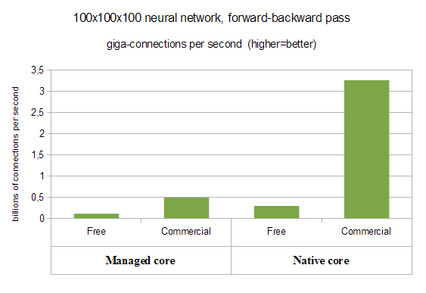

With managed core we have almost linear speed-up from multithreading (4.6x improvement over Free Edition), but native core delivers really striking results. It shows more than **11x** improvement over Free Edition (4.4x from multithreading combined with 2.6x from vectorization).

Futhermore, above we compared managed core with managed one (Free vs Commercial), native core with native one. However, if we compare worst performer (Free Edition, managed core, 0.1 gigaconnections per second) with best one (Commercial Edition, native core, 3.3 gigaconnections per second), we will get even more striking difference in processing speed - **more than 30x**!

***Test 2: single-threaded performance***

In previous test we used everything from vectorization to multithreading. It is really interesting to compare different ALGLIB editions in "maximum performance" mode. However, it is also interesting to compare single-threaded performance of managed code, generic C code and SSE-capable one.

Here "managed code" corresponds to C# core, either Free Edition - or commercial one, but used in single-threaded mode; "generic C" is C++ core, Free Edition - or commercial one in single-threaded mode and compiled without SSE support; "SSE-capable" is a Commercial Edition compiled with SSE-support.

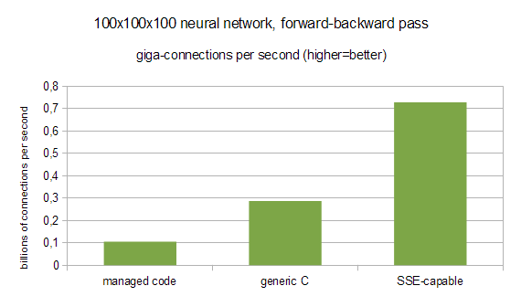

You may see that simply moving from C# to C/C++ gives us about **2.7x** performance boost, but turning on SSE support gives additional 2.5x increase in performance. If we compare best performer (Commercial Edition, native core) with worst one (managed core), we will see that difference is even more pronounced - up to **7x**!

***Test 3: multicore scaling***

In this test we'll study how performance of Commercial Edition scales with number of CPU cores. ALGLIB can parallelize following parts of neural training:

* error function evaluation (*forward pass*) - large chunks of work can be split between different cores
* gradient evaluation (*forward-backward pass*) - same as network error
* training with restarts - if you train several network from random initial states (*specify NRestarts≥2*) in order to choose best one, ALGLIB may train these networks in parallel manner.
* cross-validation - training of networks corresponding to different folds can be parallelized too.

State-of-the-art parallel framework used by ALGLIB can efficiently combine different kinds of parallelism. Say, if you train network on dataset *S* with 2 random restarts, it means than ALGLIB will create two neural networks *NET1* and *NET2*, set random initial states, and train them on *S* independently. Then, best network will be chosen and returned to you. On 1-core system ALGLIB will train *NET1*, then will train *NET2*. On 8-core system ALGLIB will train *NET1* on cores *0...3*, and *NET2* will be trained on cores *4...7*. Dataset *S* will be split between cores, so each of 4 cores assigned to network will have something to work with. Work stealing is extensively used to ensure almost 100% efficiency.

In this test we trained 50x50x50 neural network on datasets of different sizes - from 2.000 to 15.000 samples. Such network has about 5.000 connections, so overall cost of one gradient evaluation varies from 10.000.000 to 75.000.000 connection updates.

First chart (below) shows how multicore training of one network (*NRestarts=1*) scales with number of cores. Because neural training is a combination of inherently sequential and highly parallel phases, with small samples we should not expect 100% efficiency. But you may see that ALGLIB works well even for small samples (2.000 samples) - it is still beneficial to add more and more cores. However, real efficiency comes with large samples - from 5K to 15K and higher.

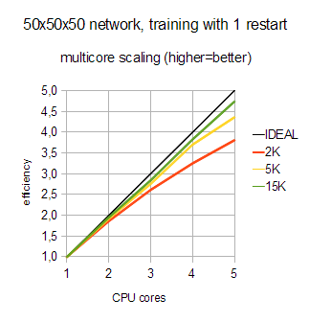

Above we solved "hard" problem - training with moderately-sizes samples and just one restart. Presence of sequential phases in the neural training limits its multicore scaling (Amdahl's law), but still we got good results. But what if we try to solve problem which is inherently parallel? Let's estimate multicore scaling of 10-fold cross-validation on dataset with 15K items.

Cross-validation involves training of ten different (and completely independent) neural networks, so it is easy to parallelize. Furthermore, large dataset size allows us to parallelize gradient evaluation, which is helpful at the last stages of cross-validation, when there are only one or two neural networks left untrained.

From the chart below you may see that efficiency is striking - **almost 100%**! We have not performed this test on system with larger number of cores, but another data we have at hand allow us to conclude that ALGLIB scales well up to tens of cores, **assuming that neural network fits into per-core cache**.

